**TERRAFORM TASK4**

Execute the script shown in video.

Downloaded the version 2.2.3

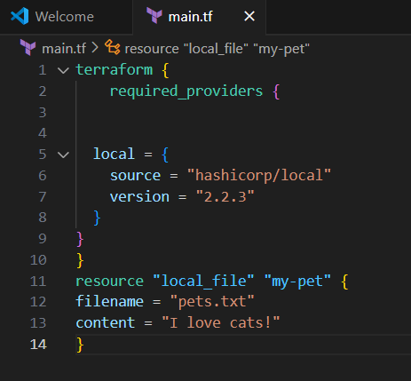

Here, it is installing the version with given specific version.

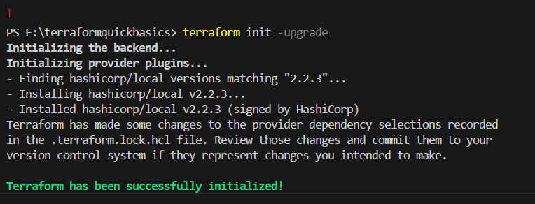

When we are using ! = in the code to the version.

By default, it is downloaded the latest version.

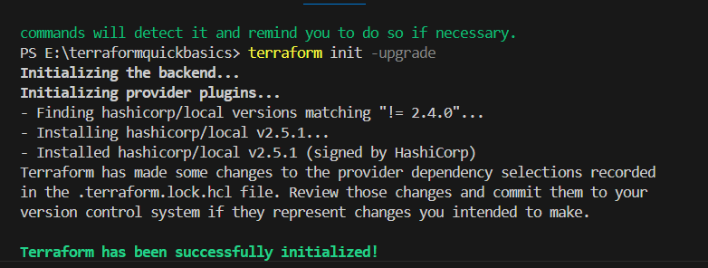

In this scenario we have used in the code “!=2.4.0,<2.3.0”

It is download according to the given version parameters

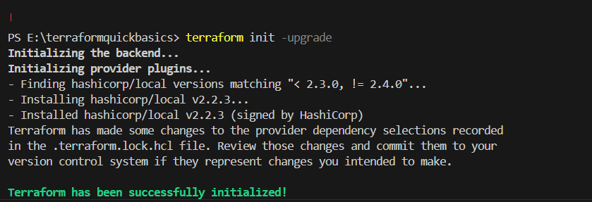

Not an ideal way because it is replacing

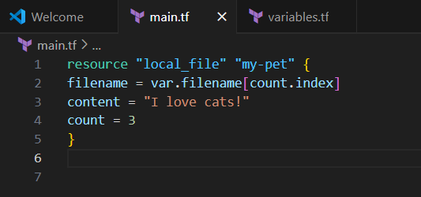

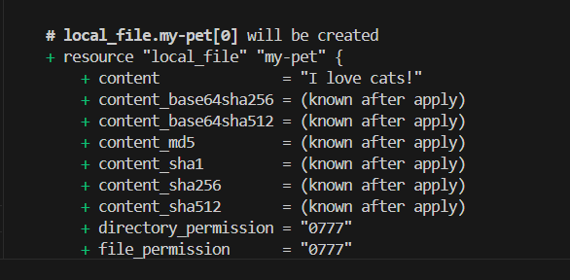

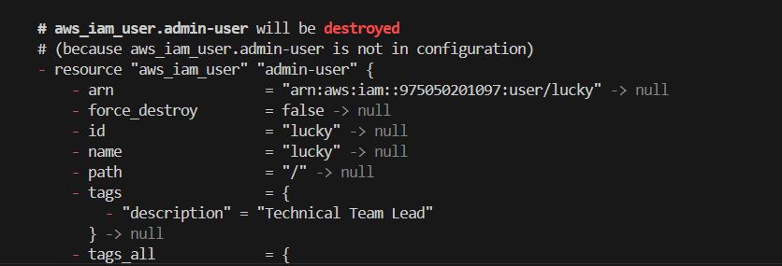

Created IAM user with the help of terraform

resource "aws_iam_user" "admin-user" {

    name = "lucky"

    tags = {

        "description" = "Technical Team Lead"

    }

}



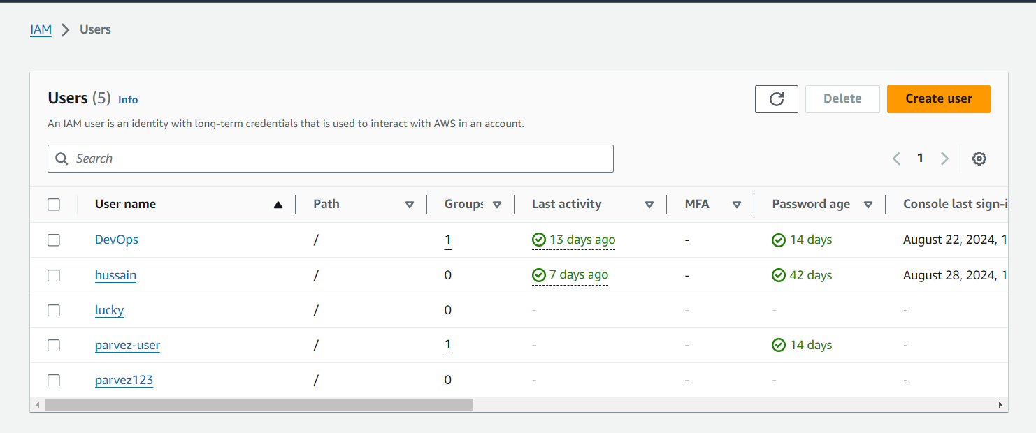

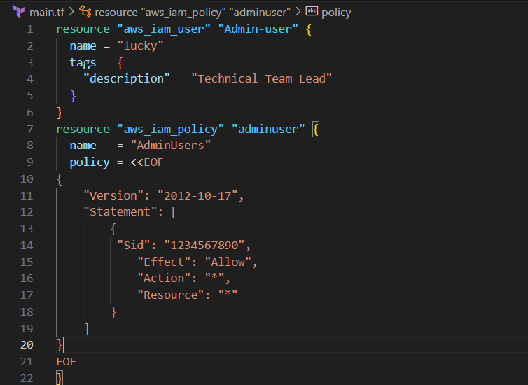

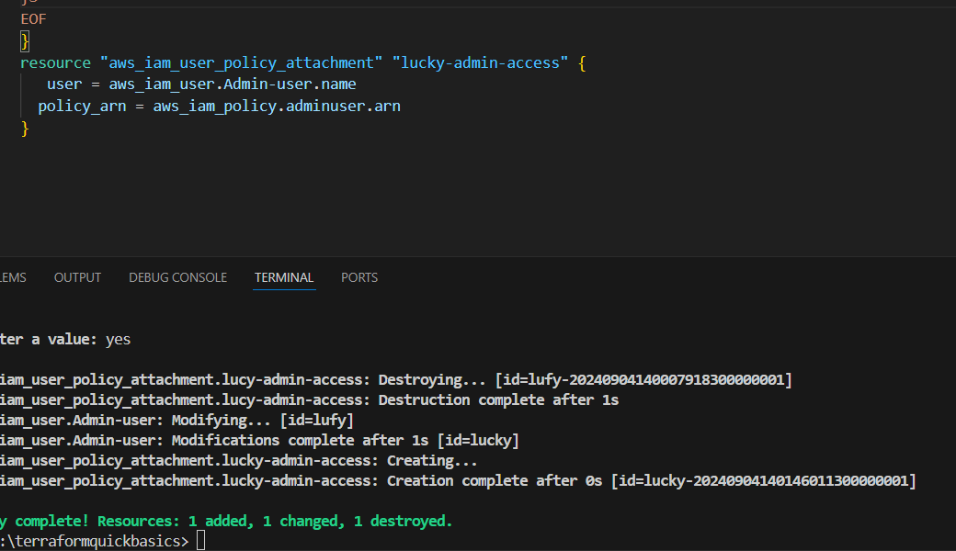

Added permissions with the help of terraform code

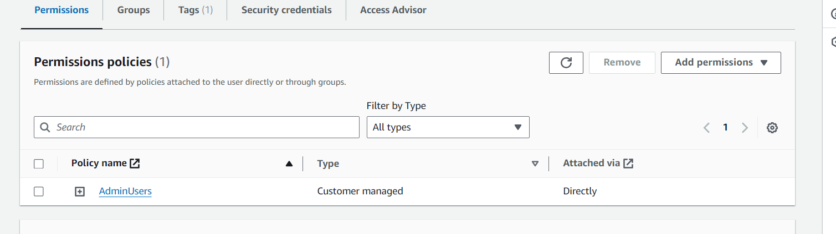

Create CICD pipeline for Nodejs Application.

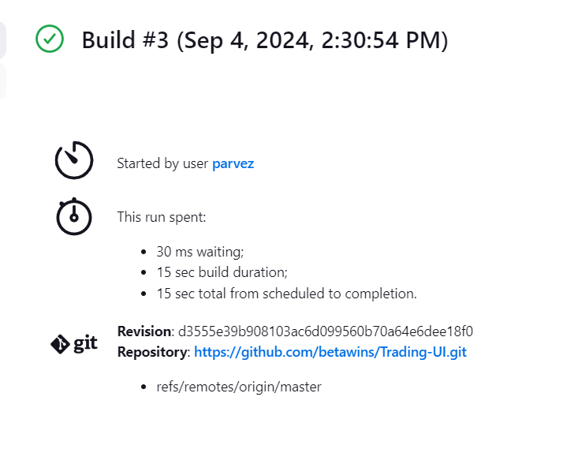

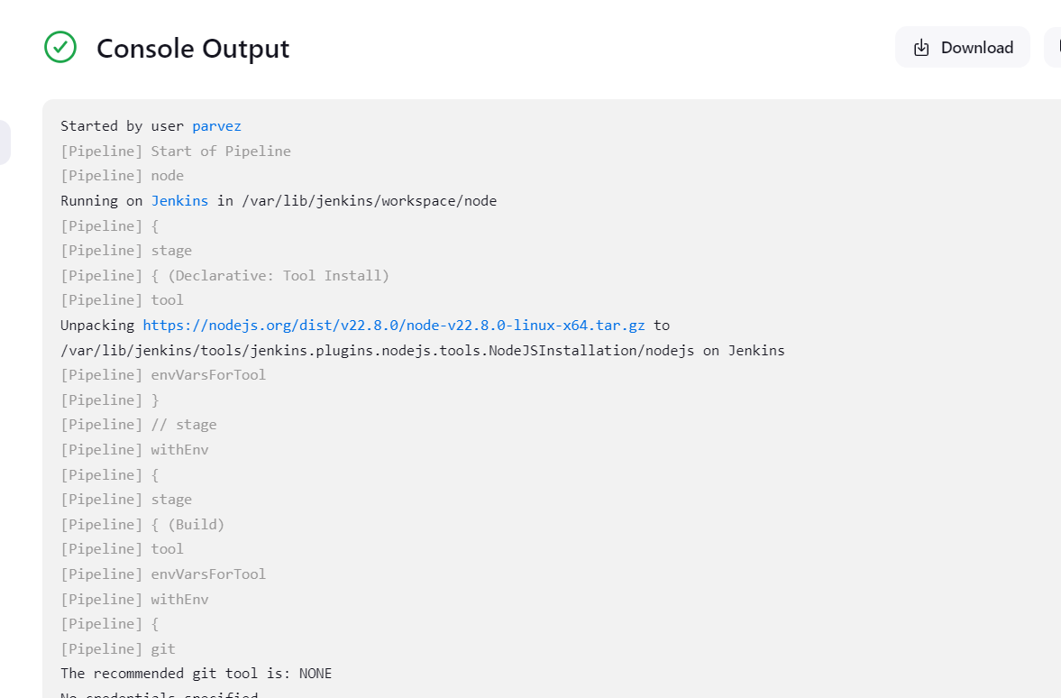

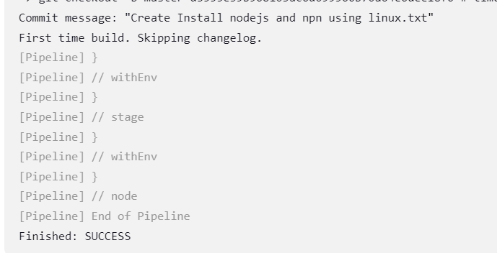

Explain 10 maven commands

1. mvn clean (This command removes the target directory and any files)
2. mvn compile (This command compiles the source code of the project.)
3. mvn test (Runs the unit tests in the project)
4. mvn package
5. mvn deploy
6. mvn validate

7.mvn clean install 8.mvn site 9.mvn site 10. Mvn dependency:tree